Introduction to Methods in C#
Objective: Introduce the concept of methods, their purpose, and how to define and call methods in a C# console application.
What are Methods?
- A method is a block of code that performs a specific task.
- Methods allow you to organize code into reusable sections, improving readability and maintainability.
- Every method has a name, may have parameters, and can return a value.
Basic Structure of a Method:
- Access Modifier: Defines the visibility (e.g., public, private).
- Return Type: What type of value the method returns (e.g., void, int, string).
- Method Name: The name of the method (e.g., GreetUser).
- Parameters (Optional): Inputs that the method can take to perform its task.
- Method Body: Contains the statements that define the method’s task.
Example
accessModifier returnType MethodName(parameters)
{
// Method body
}

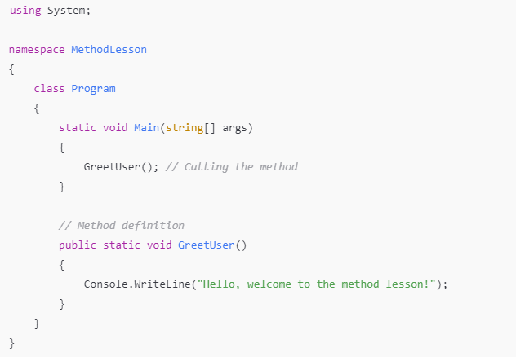

Introduction to Access Modifiers
Objective: Introduce the concept of access modifiers and their purpose in C#.
- What are Access Modifiers?
  - Access modifiers in C# are keywords used to specify the accessibility of classes, methods, and variables. They control where the code elements can be accessed.
  - Common access modifiers:
    - public
    - private
    - protected
    - internal
    - protected internal
- Overview of the Most Common Access Modifiers:
  - public: Can be accessed from anywhere.
  - private: Can only be accessed from within the same class.
  - protected: Can only be accessed from within the same class or a derived class.
  - internal: Can be accessed only within the same assembly (project)

private and public Access Modifiers
Objective: Explain the difference between private and public.
- Private Members:
  - Private members cannot be accessed outside of their class.
  - They are typically used to hide details from the user and to encapsulate the data.
- Public Members:
  - Public members can be accessed by any part of the program.
  - They are typically used to expose functionality or data to the outside.

